Online Banking Enrollment:

Go to our website at ffcocu.org. Click Login from home page or E-services/Online Banking

OR

Download the App: Search “Firefighters&Company CU Mobile”

It can be found in the Apple Store or Google Play

Click on **Sign Up** to enroll right from the app-follow steps in bold below. (Exhibit 1 back page)

Using our website (ffcocu.org) to login to online banking through your browser:

Go to Login page, go to “Your Membership” Click: Enroll in Online Banking (Exhibit 2 back page)

**Enter:**

**Social Security Number**

**Email Address (that we have on file)**

**Click Next**

**Enter Member Number: Use actual acct number**

**Date of Birth: mm/dd/yyyy**

**Select User Name:**

***Between 8 and 30 characters, Case Sensitive. Can’t be your account number.***

**Enter a Password:**

***Between 8 and 30 characters, Case Sensitive***

**Can only contain letters, numbers, and *only* the special characters listed below:**

**At symbol (@)**

**Period (.)**

**Dash (-)**

**Underscore (_)**

**Re-type Password:**

**Agree to Terms and Conditions**

**Once successfully enrolled: An activation link will be emailed to the email address you provided, *it is active for only 30 minutes*.**

**Click the Activation Link and you will now be enrolled.**

**Exhibit 1-Mobile App**

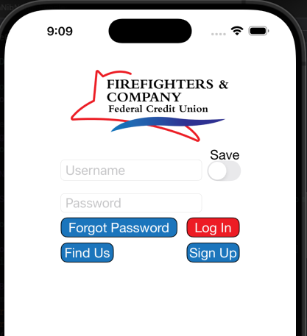

**Exhibit 2-Online Banking enrollment through ffcocu.org using your browser**