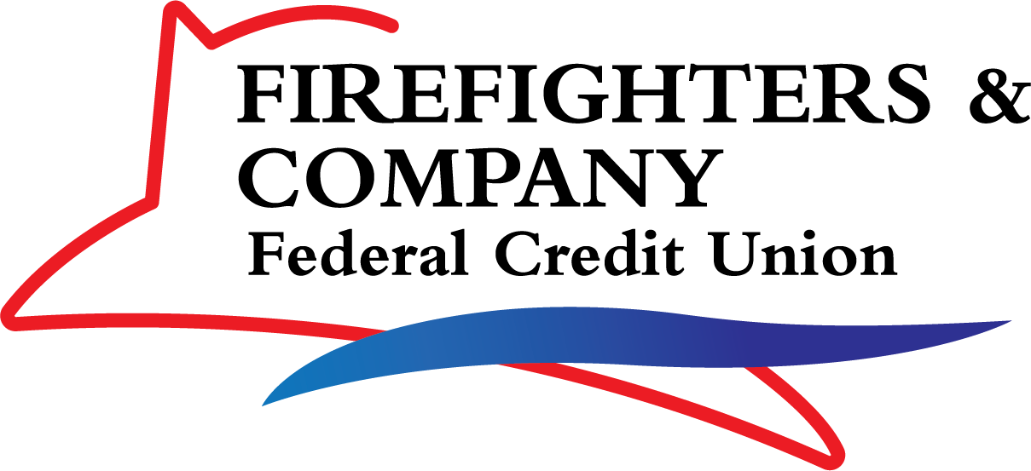

# Firefighters & Company Federal Credit Union Scholarship Guidelines

The following guidelines will apply to the application and awarding of four $2,000 scholarships to college-bound high school students or existing college students for the 2025-2026 school year.

## Eligibility Requirements

1. A new or existing Firefighters & Company Federal Credit Union (FFCOCU) member in good standing. (Membership is open to anyone that lives, works, worships or attends school in Montgomery County, Miami County, or Greene County, Ohio.) Membership can be established by opening a savings account for a minimum of $5. Applicants must be a FFCOCU member to be considered for the scholarship.
2. A graduating high school senior or an existing college student who is enrolled full time.
3. GPA of a least 2.5 (on 4.0 scale).

## Application Requirements

1. A completed Firefighters & Company Federal Credit Union Scholarship Application.
2. A completed essay.
3. Verification of student’s individual account at FFCOCU.

## Award Criteria

1. School Activities/Work Experience (25%)
2. Essay (75%)
3. Acceptance into a two-year community college or four-year university
4. Full-time enrollment of 12 or more credits/units.

## Timelines

1. Firefighters & Company Federal Credit Union Student Scholarship applications will be available April 7, 2025.
2. Completed applications must be received by the credit union by close of business on June 6th, 2025.
3. Scholarships will be to the top four students. After confirmation of registration and acceptance at school, award checks will be made out to the college.

**Please print or type. Use additional paper if more space is needed.**

## CONTACT INFORMATION

Name: Last First Middle

FFCOCU Acct # Date of Birth: Address: City: State: Zip: Phone: ( ) Email: @ **SCHOOL INFORMATION**

High School/College Attending now:

High School/College Address: City: State: Zip:

High School/College Telephone ( ) Cumulative Grade Point Average

High School Graduation Date *(Mo./Yr.)*

College/University You Plan to Attend or are Attending in the Fall:

Address City: State: Zip: Planned Major: **EXPERIENCE**

Please list scholastic awards and achievements:

Please list your extracurricular activities:

Please list your community involvement:

Please list your work experience:

# Essay:

Please answer the following question by attaching your typed double-spaced response. Essay answers should not be longer than four pages.

**Every generation has certain positive and negative characteristics. What are the pros and cons of your generation? What can you do to help promote the good and change the bad? Be specific. Name specific examples of some of the challenges and successes in your own life as it relates to finances?**

**Please return this completed application and essay to: Firefighters & Company Federal Credit Union 338 South Patterson Blvd. Dayton OH 45402. Attention: FFCOCU Scholarship**

Applications must be received by Firefighters & Company Federal Credit Union close of business on June 6th, 2025. Applicants must be a FFCOCU member in good standing as of date application is submitted, and a graduating high school senior in the 2025 school year or an existing college student or enrolled full time in college in 2025/2026 school year. Applications will not be returned and will become the property of FFCOCU. FFCOCU officers, employees and their immediate or extended families are not eligible. The winning entries will be chosen at the discretion of FFCOCU. Winners will be notified by August 8th via email or phone and agree to have their names/photos published in FFCOCU promotional materials. After confirmation of registration and acceptance at a two-year community college or a four- year university, for 12 or more credits/units in classes, award checks will be made out to the school. If you have any questions, please contact Tammi Coffey, Member Service Concierge at 937-228-1614 or e-mail [tlehn@ffcocu.org](mailto:tlehn@ffcocu.org).

The undersign authorizes the use and reproduction by the Firefighters & Company Federal Credit Union (FFCOCU) or its agents or anyone else authorized by FFCOCU, the right to use any and all photographs and writings for the purpose of publicity, advertising, and web content in connection with FFCOCU in print or electronically.

Student/Applicant Date

Parent Signature (if applicant is under 18 years of age) Date